**Use Case Diagram**

**Fully Dressed Use Cases**

[Fully Dressed Use Case.docx](https://asiapacificcollege.sharepoint.com/:w:/s/HecTech2/EYXbWgj3s3FKuW6bKkDe5noBAMpvmr0dB0rRTgqpJpLWMw?e=4yWIv4)

**Data Flow Diagram**

# **Level 0 (Context Diagram)**

# **Level 1**

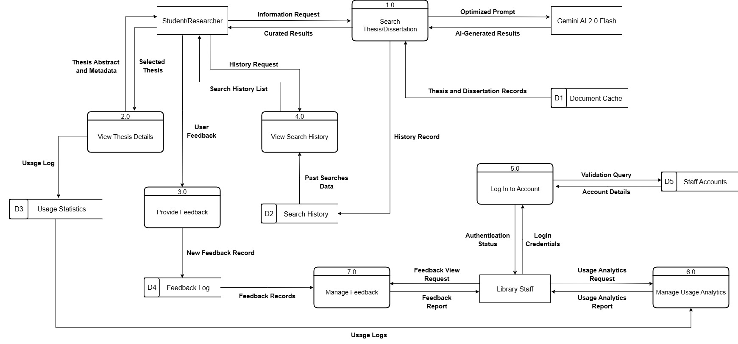

# **Level 2**

## **1.0 Search Thesis/Dissertation**

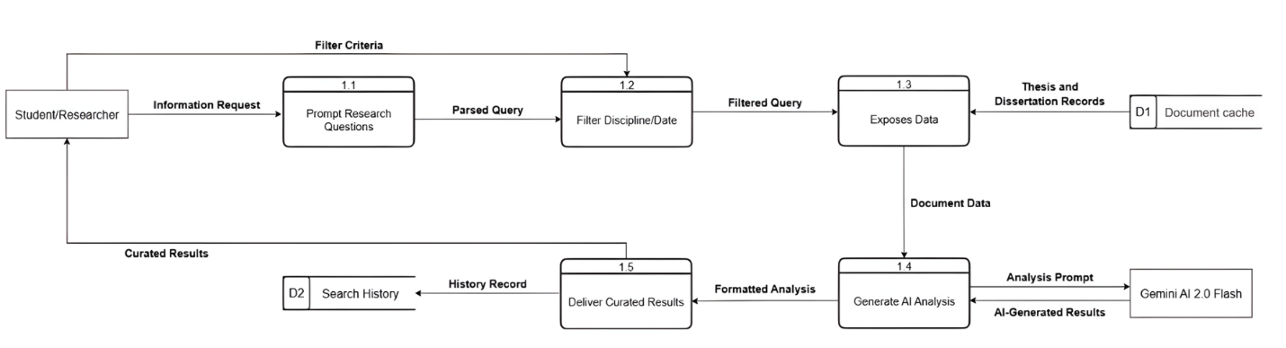

## **2.0 View Thesis Details**

## **3.0 Provide Feedback**

## **4.0 View Search History**

## **5.0 Log In to Account**

## **6.0 Manage Usage Analytics**

## **7.0 Manage Feedback**

# **Activity Diagrams**

## **1.0 Search Thesis/Dissertation**

**6.0 Manage Usage Analytics**  
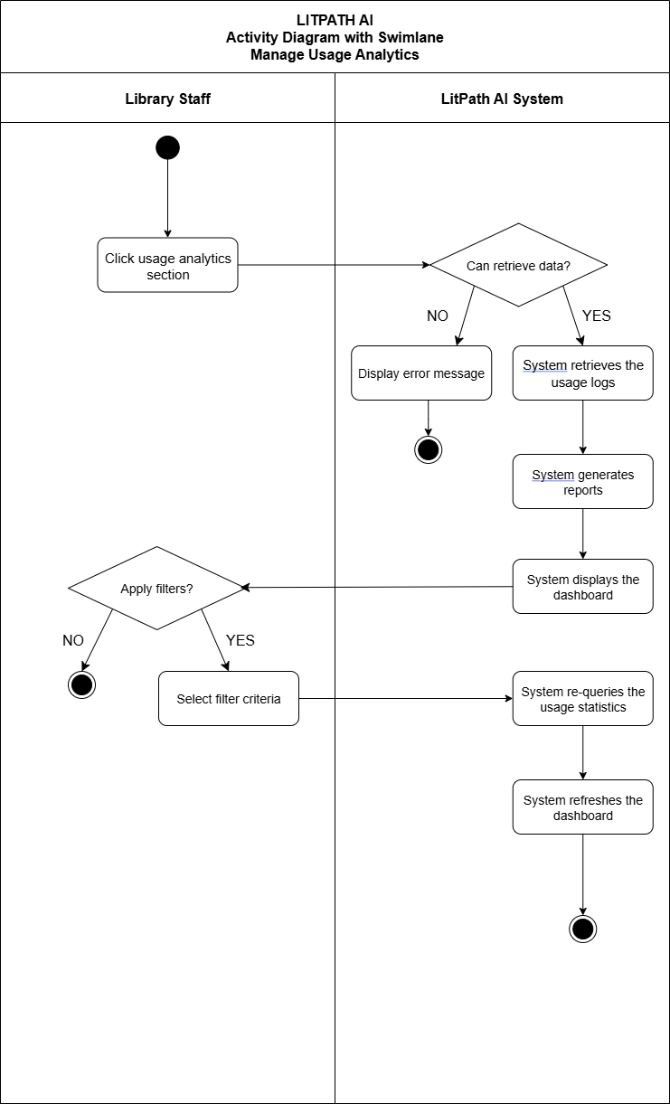

# **Entity Relationship Diagram**

# **Data Dictionary** [**data_dictionary**](https://asiapacificcollege-my.sharepoint.com/:x:/g/personal/ctcempron_student_apc_edu_ph/EeE58DgcoKVNnAfLrtGrLScBG-6TM3GoJDLI-USFUuuu9A)